**17.ROČNÍK JAKLOVSKÝCH PRETEKOV AGILITY**

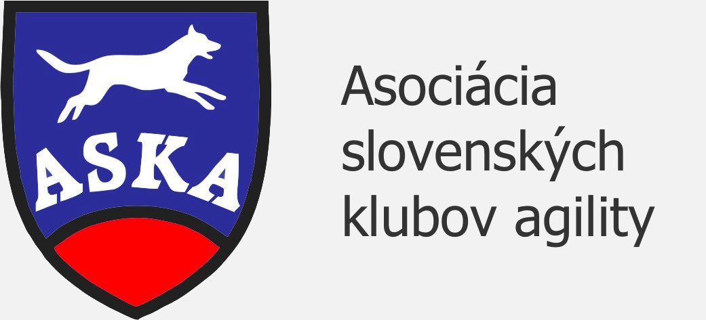

**Date**: 14.6. – 15.6.2025  
**Venue:** Areál ŠK Severan Jaklovce, Slovensko 48.876401, 20.994213  
**Judge**: Adela Havlíčková   
**Guarantee:** Jaroslav Krupár  
**Max number of competitors**: 100  
**Surface:** Grass

**Contact obstacles:** Bing

**Electronic timer**

**Program:**  
**Saturday:** 7:45-8:45 presentation  
9:15-9:30 opening ceremony  
9:30 course walk

Open Agility I, Exams I. (A1, A2, A3),  
Open Jumping I,

**Sunday:** 8:00-8:45 presentation  
9:15 course walk  
Open Agility II, Exams II. (A1, A2, A3)  
Open Jumping II.

**Starting fee:** 1 team (handler+dog) 40€ for **2 days** if competing with multiple dogs + 25€ per every supsequent dog

1 team (handler+dog) 30€ for **1 day** if competing with multiple dogs + 20€ per every supsequent dog

Competitors para agility don´t pay the starting fee.  
Foreign competitors have the option to pay on the spot.  
Starting fee includes refreshments.

**Aplication deadline: 09.06.2025**

**The payment must be cleared before 11.06.2025**

**Awarding:** Summary of Open Agility and Open Jumping SATURDAY + SUNDAY.

Exams will be concluded each day.

**Warning:**

The organizer reserves the right to change the propositions and/or not accept applications without specifying the reason.

In the case of competition cancellation by force majeure the entry fee remains for the organizer.

**In case of any changes in registration the organizer must be notified before 11.06.2025. After 11.06.2025 no changes will be accepted.**

**General terms:**

The competition is held according to the ASKA rules. The handler is responsible for all damages caused by his/her dog. The organizer reserves the right to change the program. Dog walking is possible outside the competition area as per organizer’s guidelines. The handler is required to pick up feces after their dog. Protestation may be filled after 30€ deposit payment only.  
**Lodging:**  
In the area there is plenty room to park your mobile home or put up tents.  
**Veterinary conditions:**

Valid vaccination not only against rabies but also polyvalent vaccination against other infections recorded in Vaccination book or Petpass. Every dog must be microchiped.

**Registration:**  
Online registration at [**www.agilityportal.sk.**](http://www.agilityportal.sk/?fbclid=IwZXh0bgNhZW0CMTAAAR3W_MQipMY2j9Cfxohj0UZKM2S5N0zxWDJpkE9y7nG1RTy46X-PPwwBKJE_aem_6tTROCH7hR9tOUvq5t_2pg) Starting fee by bank transfer:

IBAN: SK5383300000002601715000  
  
Contact: Jaroslav Krupár, Úvozná 205, 055 61 Jaklovce, Slovenská republika

Daniela Janošková

E-mail: [jaroaslavka@gmail.com](mailto:jaroaslavka@gmail.com)

danielajanoskova02@gmail.com  
Tel.: Jaroslav Krupár: +421 907 320 348

Daniela Janošková +421 919292660